
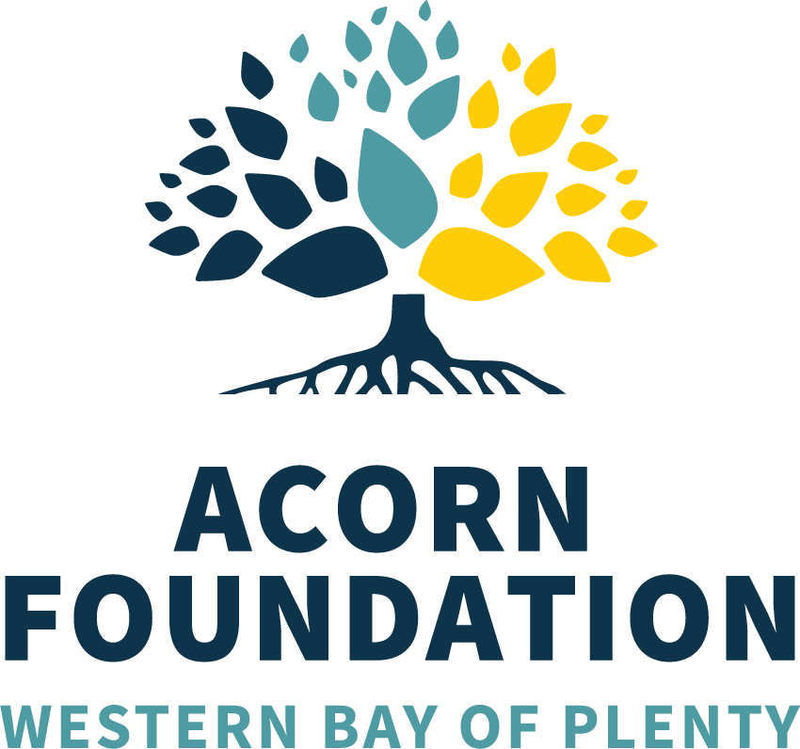

Acorn Foundation Christine Tustain Sports Award

About Christine Tustain:

Chris is a great fan of all sports, performing arts and classical music, and she is a generous supporter of animals and the environment. As a passionate traveller, she has visited no less than 80 countries, and climbed Mount Kilimanjaro. She is a past volunteer of Hato Hone St John and Tauranga Hospital. She is an avid tennis player, being involved at the Otumoetai Tennis Club since 1980, where she has been treasurer and club captain at different times. These days Chris enjoys keeping fit with her tennis, cycling, walking and swimming.

She has been an incredibly generous supporter of young athletes since 2015, assisting 12 individuals to reach their goals. She has also supported 10 performing artists and classical musicians to hone their art.

Chris’s support of her community is nothing short of remarkable!

Purpose

This award is to recognise the sporting talent found within the Western Bay of Plenty amongst our junior athletes and is designed to assist high achieving young athletes with further development and/or pathways to achieve their goals in international competitions.

Eligibility and criteria

Eligible athletes must:

- Be studying, training or working in the Western Bay of Plenty at the time of the application.
- Be aged between 16 – 23 at the time of application
- Have achieved national representation at their sport.
- Be continuing in their chosen sport and will be able to outline their pathway towards international competitions.

Note:
- No funding will be provided retrospectively.
- Athletes attending university outside of the Western Bay of Plenty do not qualify for this scholarship.

SCHOLARSHIP VALUE

This scholarship has a total value of $2,000. This scholarship has been kindly donated by Christine Tustain through the Acorn Foundation and will be awarded in (approximately) March of each year. The scholarship may be awarded to one successful recipient or, on occasion, may be split between no more than two successful recipients.

Requirements

- Applicants must submit a personal statement outlining the reasons why they think they are suitable for this award.
- Applicants must outline their previous achievements in sport.
- Applicants must also submit two references:
  - One character reference; and
  - A second reference from their coaches, mentors or education providers.

- Scholarships must be for sporting competition/educational or development purposes, with the ultimate aim to compete at international level.
- Applications will be assessed by Sport BOP in the first instance, with the final decision being made by the Acorn Foundation/Christine Tustain.
- Successful applicants will be asked to provide a written thank you letter to the donor and assist Sport Bay of Plenty and/or the Acorn Foundation with promotional material.
- Regular updates of progress towards desired outcomes will be expected.
- Applications will be considered depending on the event, priority will be given in order to Olympic Qualification, World Championships (senior), Commonwealth Games, World Champs (junior), New Zealand Event Representation, Development Tour Events, New Zealand Secondary School events.

APPLICATION PROCESS

Applications will be made directly with Sport BOP and must be submitted before the close off date of Sunday 4 May 2025.

At the close of applications a short listed group of coaches may be contacted by representatives of Sport Bay of Plenty.

All enquiries and applications must be received by Sunday 4 May 2025 to:

Jarvy Aoake
SPORT BAY OF PLENTY
PO Box 13355, Tauranga.
Phone 07 578 0016 x 844
Email: jarvya@sportbop.co.nz

